Project Design Phase-II
Data Flow Diagram & User Stories

Date | 14 March 2025
Team ID | SWTID1743498710
Project Name | I-Movies: Movie Ticket Booking System
Maximum Marks | 4 Marks

Data Flow Diagrams:
The user interacts with the system to register, login, browse movies, book tickets, and make payments. The system stores and retrieves data from MongoDB and uses Firebase for authentication and image handling. External payment gateways handle transactions.

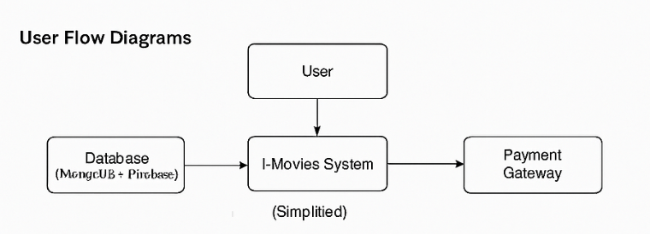

User Stories

User Type | Functional Requirement (Epic) | User Story Number | User Story / Task | Acceptance criteria | Priority | Release
Customer (Mobile user) | Registration | USN-1 | As a user, I can register for the application by entering my email, password, and confirming my password. | I can access my account / dashboard | High | Sprint-1
Customer (Mobile user) | Registration | USN-2 | As a user, I will receive confirmation email once I have registered for the application | I can receive confirmation email & click confirm | High | Sprint-1
Customer (Mobile user) | Registration | USN-3 | As a user, I can register for the application through Facebook | I can register & access the dashboard with Facebook Login | Low | Sprint-2
Customer (Mobile user) | Registration | USN-4 | As a user, I can register for the application through Gmail | I can register & access dashboard via Gmail | Medium | Sprint-1
Customer (Mobile user) | Login | USN-5 | As a user, I can log into the application by entering email & password | I can log in and view my homepage/dashboard | High | Sprint-1
Customer (Web user) | Browse Movies | USN-6 | As a user, I can browse currently available movies | I can see movie list with posters and info | High | Sprint-2
Customer (Web user) | Showtimes & Seats | USN-7 | As a user, I can select showtime and pick seats | I can view seat layout and choose available seats | High | Sprint-3
Customer (Web user) | Booking | USN-8 | As a user, I can confirm and pay for tickets | I receive booking ID and confirmation | High | Sprint-3
Customer (Web user) | Booking History | USN-9 | As a user, I can see my previous bookings | I see list of past bookings | Medium | Sprint-4
Customer Care Executive | Manage Bookings | USN-10 | As a support agent, I can view user bookings and help with cancellations | I can search by email/booking ID | Medium | Sprint-4
Administrator | Movie Management | USN-11 | As an admin, I can add/edit/delete movie entries | Changes reflect in the movie listings | High | Sprint-4
Administrator | Show Management | USN-12 | As an admin, I can schedule or update showtimes | Updated shows are visible to users | Medium | Sprint-4

